Traffic Simulating System
Use-Case Specification: <Use-Case Name>Load map

Version 2.0
Revision History
Date | Version | Description | Author
05/Oct/2008 | 1.0 | Draft | Mohan Yang
01/Jan/2009 | 2.0 | Final Version | Mohan Yang

Table of Contents
1. Load map 4
1.1 Brief Description 4
2. Flow of Events 4
2.1 Basic Flow 4
2.2 Alternative Flows 6
3. Special Requirements 7
3.1 XML file format 7
4. Preconditions 8
5. Postconditions 8
6. Extension Points 8
6.1 Traffic light 8
6.2 Design road 8

Use-Case Specification: <Use-Case Name>Load map

Load map

Brief Description
This use case allows a city planner to load a road map from road information system. The road information system will provide the data through an xml file and the traffic simulating system read the file and shows the correspondent map to the city planner.
The main actor of this use case is the City Planner. The road information system is an actor within the use case.

Flow of Events

Basic Flow
- The city planner starts the system.
- The system constructs an empty map.
- The system initializes the specified road information system.
- The system retrieves the road list from the road information system and adds the roads in the list into the created map.
- The system initializes the specified console.
- The system sends the map to the console and the console handles the map creating event.
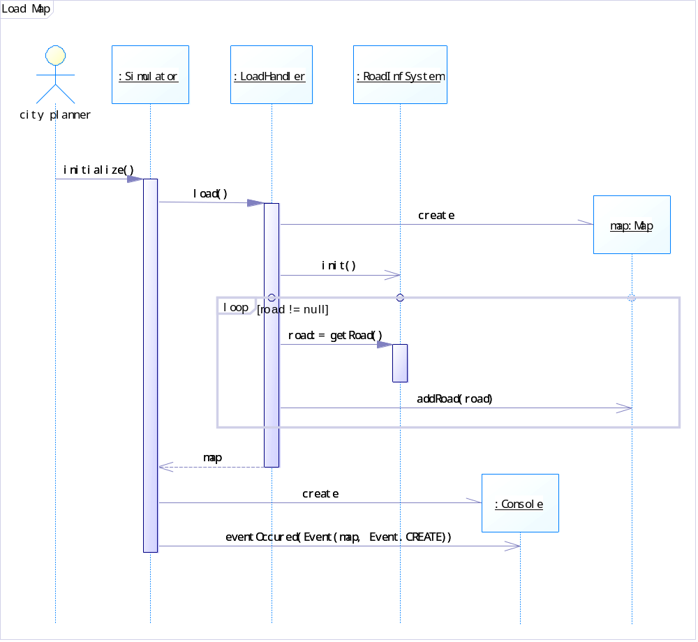
Graph 1 Sequence Diagram of Basic Flows

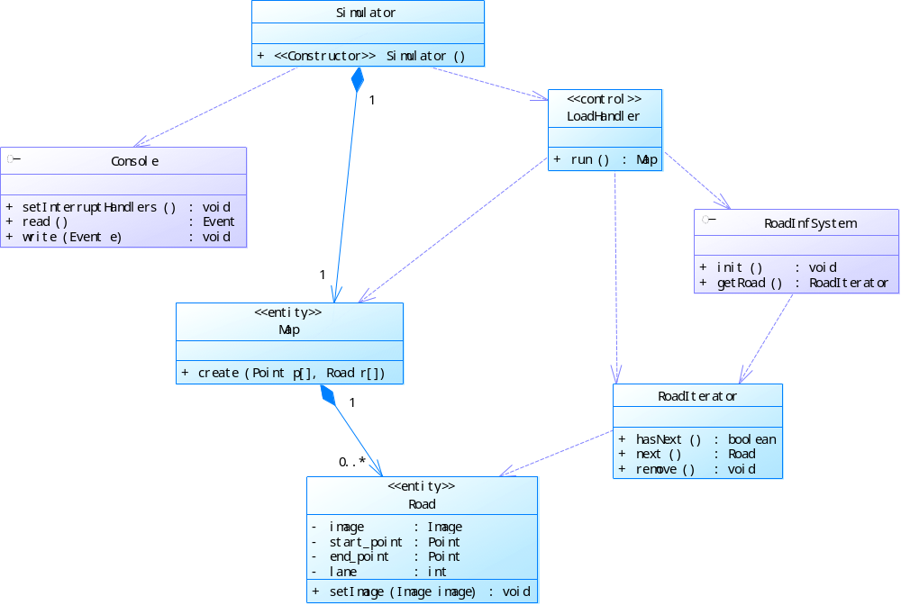
Graph 2 Class Diagram of Load Map

Alternative Flows
6a. Display Map of command line mode console
If the specified console is the command line mode console, the system just traverses through the map and output every point and road in the map.
6b. Display Map of graphic mode console
If the specified console is the graphic mode console, the flow of handling the map creating event is as follows.
- The console dispatches the map to the UI.
- The UI initializes the display environment.
- The UI traverses through the road in the map and draw the road on the screen.
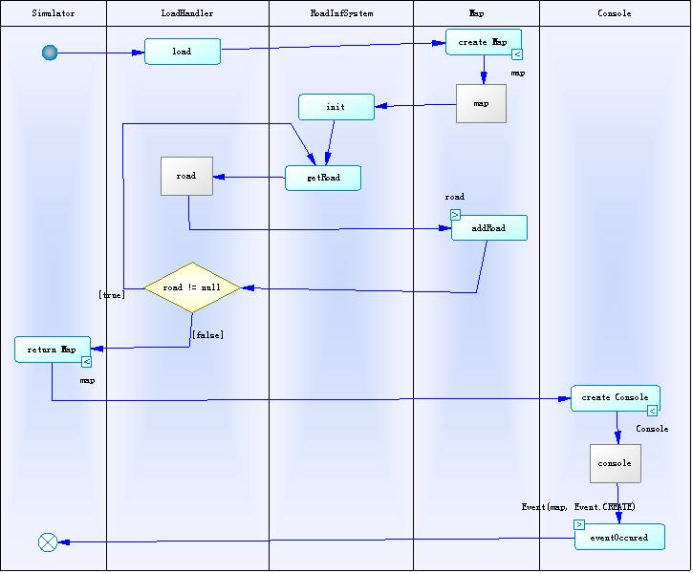
Graph 3 Activity Diagram of Load Map

Special Requirements

XML file format
The map information should be passed through an XML file and the format of the XML file should be specified. The following is the format of the XML file in the implementation of the system.
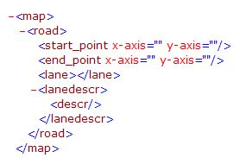

Preconditions
There are no preconditions associated with this use case.

Postconditions
There are no postconditions associated with this use case.

Extension Points

Traffic light
Allow city planners adding traffic light in the map. At each point, the number of traffic lights is equal to the degree of the point and these traffic lights will form a group working together to ensure the vehicle move correctly. The traffic lights belong to the same group will work without confliction.
The adding of traffic light will be implemented by adding a data type in the XML file and the road information system will read these data and the system will draw them on the map.

Design road
Allow city planners draw all shapes of roads on the map. After loading the main map, the UI will enable city planners drawing roads on the map just like draw curves in a painting program.

